Consumir un srevicio WCF, que envía el nombre del cliente y el servicio entregue la información de capacidad de endeudamiento según información enviada.

Para ello debe crear:

* Schemas. Customer y Loan
* Maps: para la transformación del mensage
* Orchestration: donde recibira el mens lo procesará y lo enviará
* Debe incluir un itinerario a la orchestration y configurarlo en la entrada.

Create schemas:

|  |
| --- |
|  |

|  |  |
| --- | --- |
|  |  |

In Maps agreque la referencia del Proyecto schemas

|  |
| --- |
|  |

Cree la transformación Loan

|  |
| --- |
|  |

|  |
| --- |
|  |

Build and Deploy de projects. This is mandatory before to create the Itinerary .

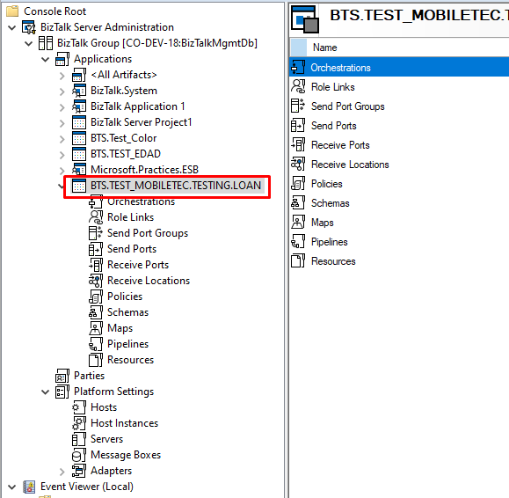}

Deploy manually the application

|  |
| --- |
|  |

Now Create the WCF Publish service with the schema customer

|  |
| --- |
|  |

|  |
| --- |
|  |

|  |
| --- |
|  |

|  |
| --- |
|  |

As the WCF will be consumed and the response will be sent to a folder, select webmethod like One-Way.

This Method OnWay will create two binding in the Orchestration.

|  |
| --- |
|  |

Select the .dll for schemas

|  |
| --- |
|  |

|  |
| --- |
|  |

|  |
| --- |
|  |

Select name space

|  |
| --- |
|  |

|  |
| --- |
|  |

|  |
| --- |
|  |

Note that a RP and RL has been created

|  |
| --- |
|  |

Change the name for them

|  |
| --- |
|  |

RL

|  |
| --- |
|  |

Now hat we have deployed the application and created the RP, we can proceed to create the Itinerary.

Propiedades del model

|  |
| --- |
|  |

|  |
| --- |
|  |

Arrastre un Onramp and select Extender as shown.

|  |
| --- |
|  |

Select Biztalk application and receive port properties

|  |
| --- |
|  |

|  |
| --- |
|  |

Now to configure the service name , as orchestration name, you must firs select as shown and then edit the .itinerary file.

|  |
| --- |
|  |

Open the ititnerary project folder

|  |
| --- |
|  |

|  |
| --- |
|  |

|  |
| --- |
|  |

|  |
| --- |
|  |

You can see the srevicename has been changed to the fully Orch name

|  |
| --- |
|  |

Add a connector

|  |
| --- |
|  |

Export Model

|  |
| --- |
|  |

Check database

|  |
| --- |
|  |

As status is 0, export it again but with itinerarystatus = deployed

|  |
| --- |
|  |

Check database again

|  |
| --- |
|  |

Now go to Orchestration and add the filter to Receive Message. Previous add reference to the libraries from

*C:\Program Files (x86)\Microsoft BizTalk ESB Toolkit\Bin\Microsoft.Practices.ESB.Itinerary.Schemas.dll*

|  |
| --- |
|  |

|  |
| --- |
|  |

Now create the filters

|  |
| --- |
|  |

Set this values:

ServiceName: project name + orchestration name ("Orchestration.Mobiletec.Testing.Loan.Process_Loan_Calculation.Mobiletec.Testing.Loan")

Servicestate . “Pending”

SreviceType : "Orchestration"

|  |
| --- |
|  |

Build again the Project and updated from console.

|  |
| --- |
|  |

Go to console and update the .dll

Configure the orchestrations

|  |
| --- |
|  |

Configure the Receive Location to **Receive Pipeline: ItinerarySelectReceive**

**SP to fOLDER**

|  |
| --- |
|  |

|  |
| --- |
|  |

|  |
| --- |
|  |

Now Configure the Pipeline of the itinerary of the Receive Location

|  |
| --- |
| Resolver.Itinerary  ITINERARY:\\name=Itinerary_Loan |

|  |
| --- |
|  |

Configure the site

|  |
| --- |
|  |

|  |
| --- |
|  |

|  |
| --- |
|  |

Check the web service

|  |
| --- |
| <http://co-dev-18.mobiletec.local/MobiletecTestingLoan/WcfLoan.svc?wsdl> |

Check Sp folder

|  |
| --- |
|  |